Name: Y Guru Charan
Reg No: 192565020
Course Name: Computer Networks for Software Application
Code: CSA0713

- Configuration of DHCP (dynamic host configuration protocol) in packet Tracer

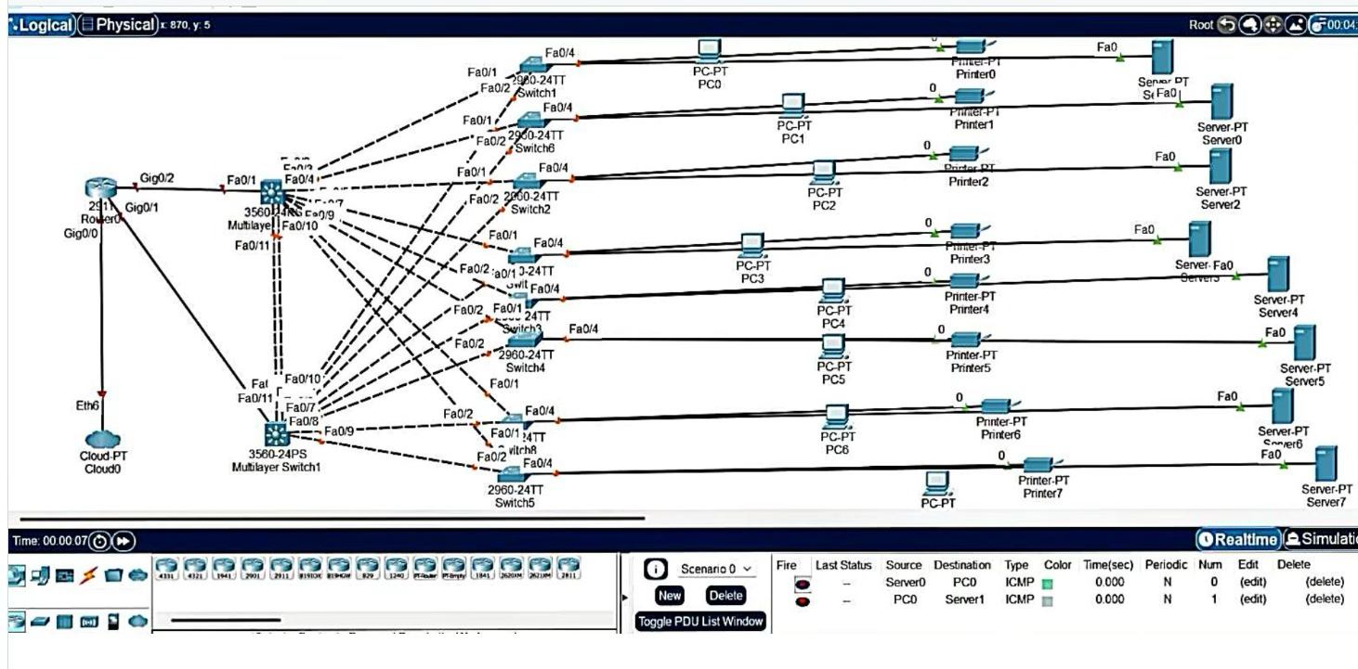

- Configuration of firewall in packet tracer.

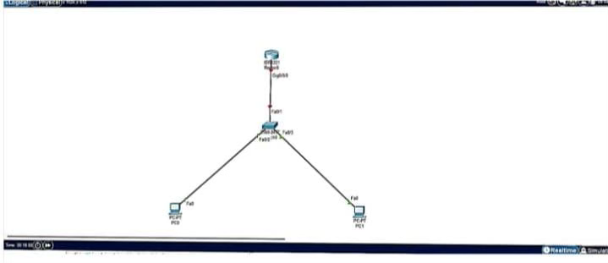

- Make a Computer Lab to transfer a message from one node to another to design and simulate using Cisco Packet Tracer

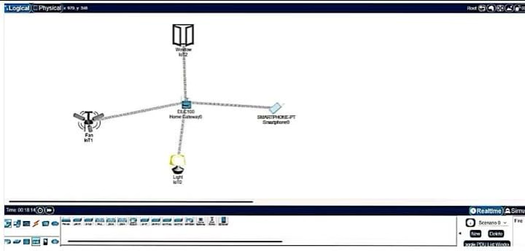

- Simulate a Multimedia Network in Cisco Packet Tracer.

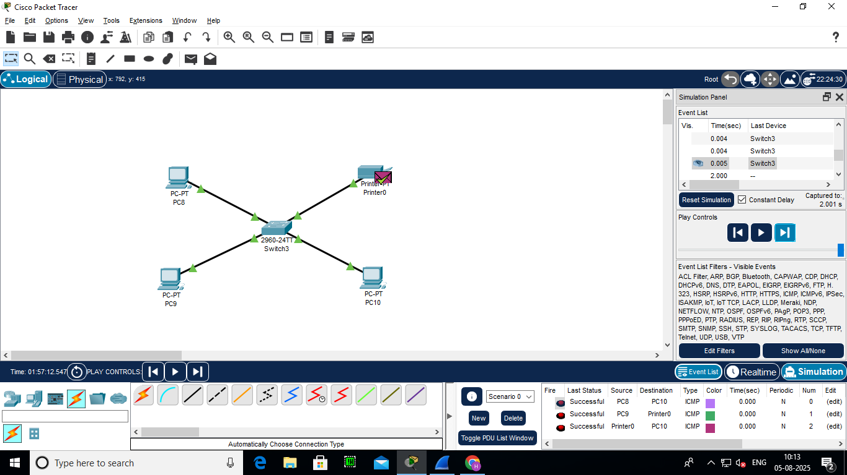

- IoT based smart home applications.

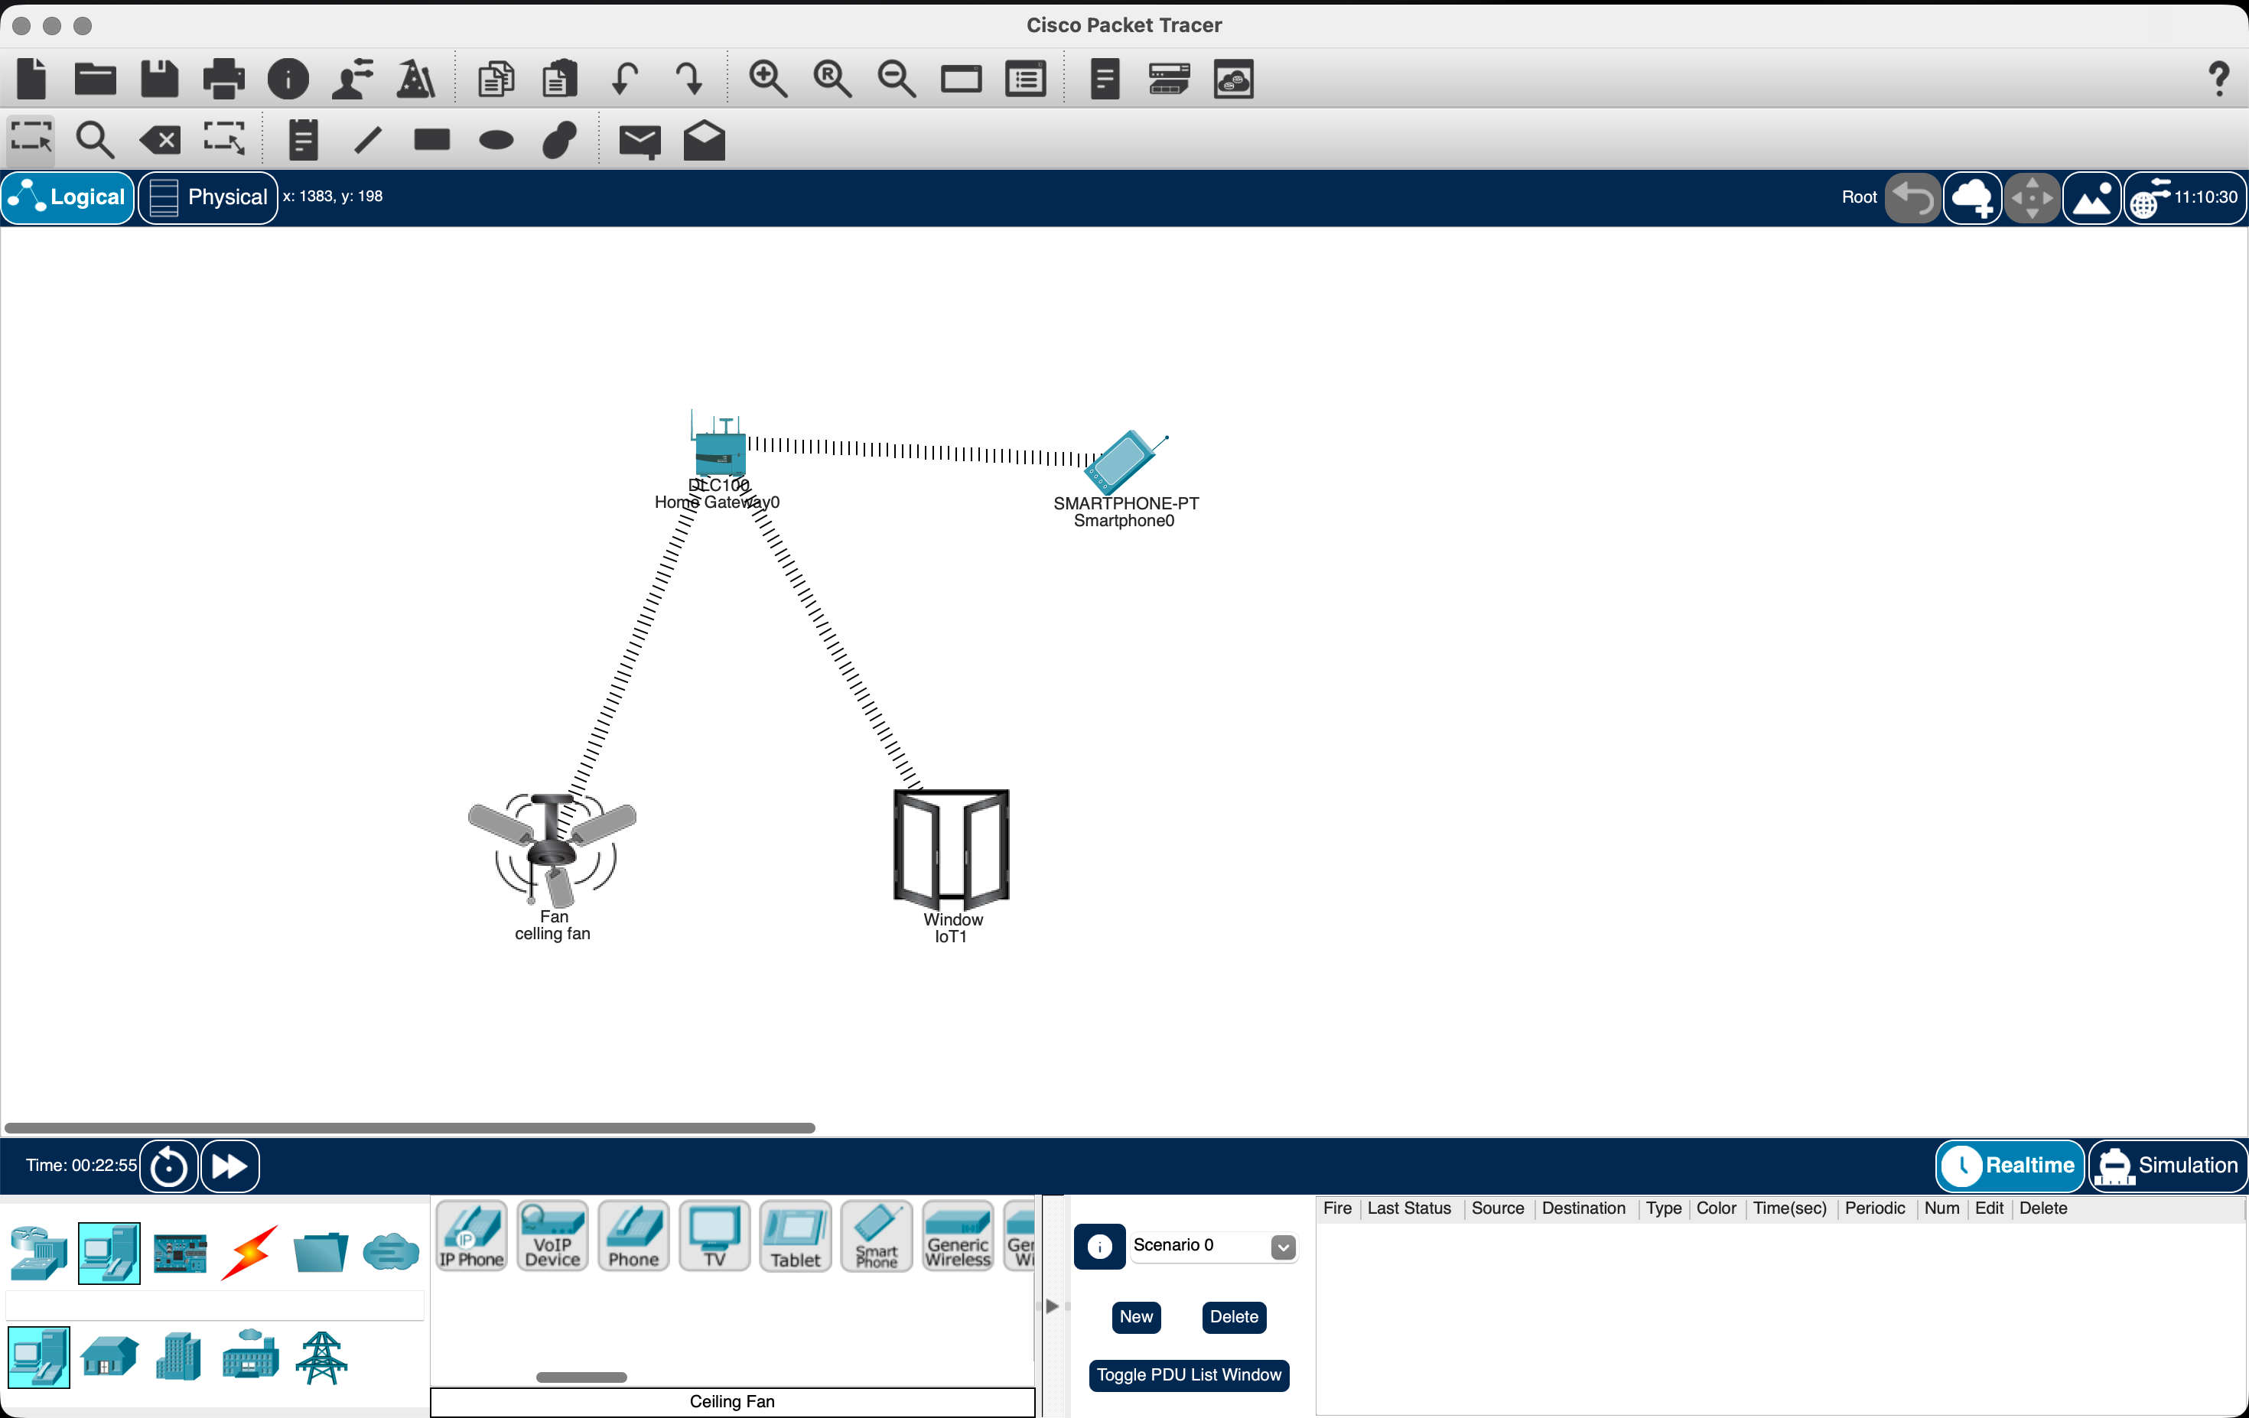

- Implementation of IoT based smart gardening.
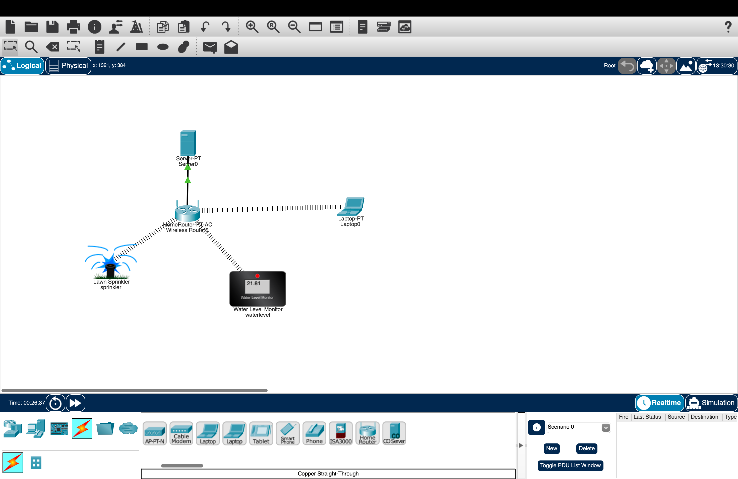

- Implementation of IoT devices in networking.
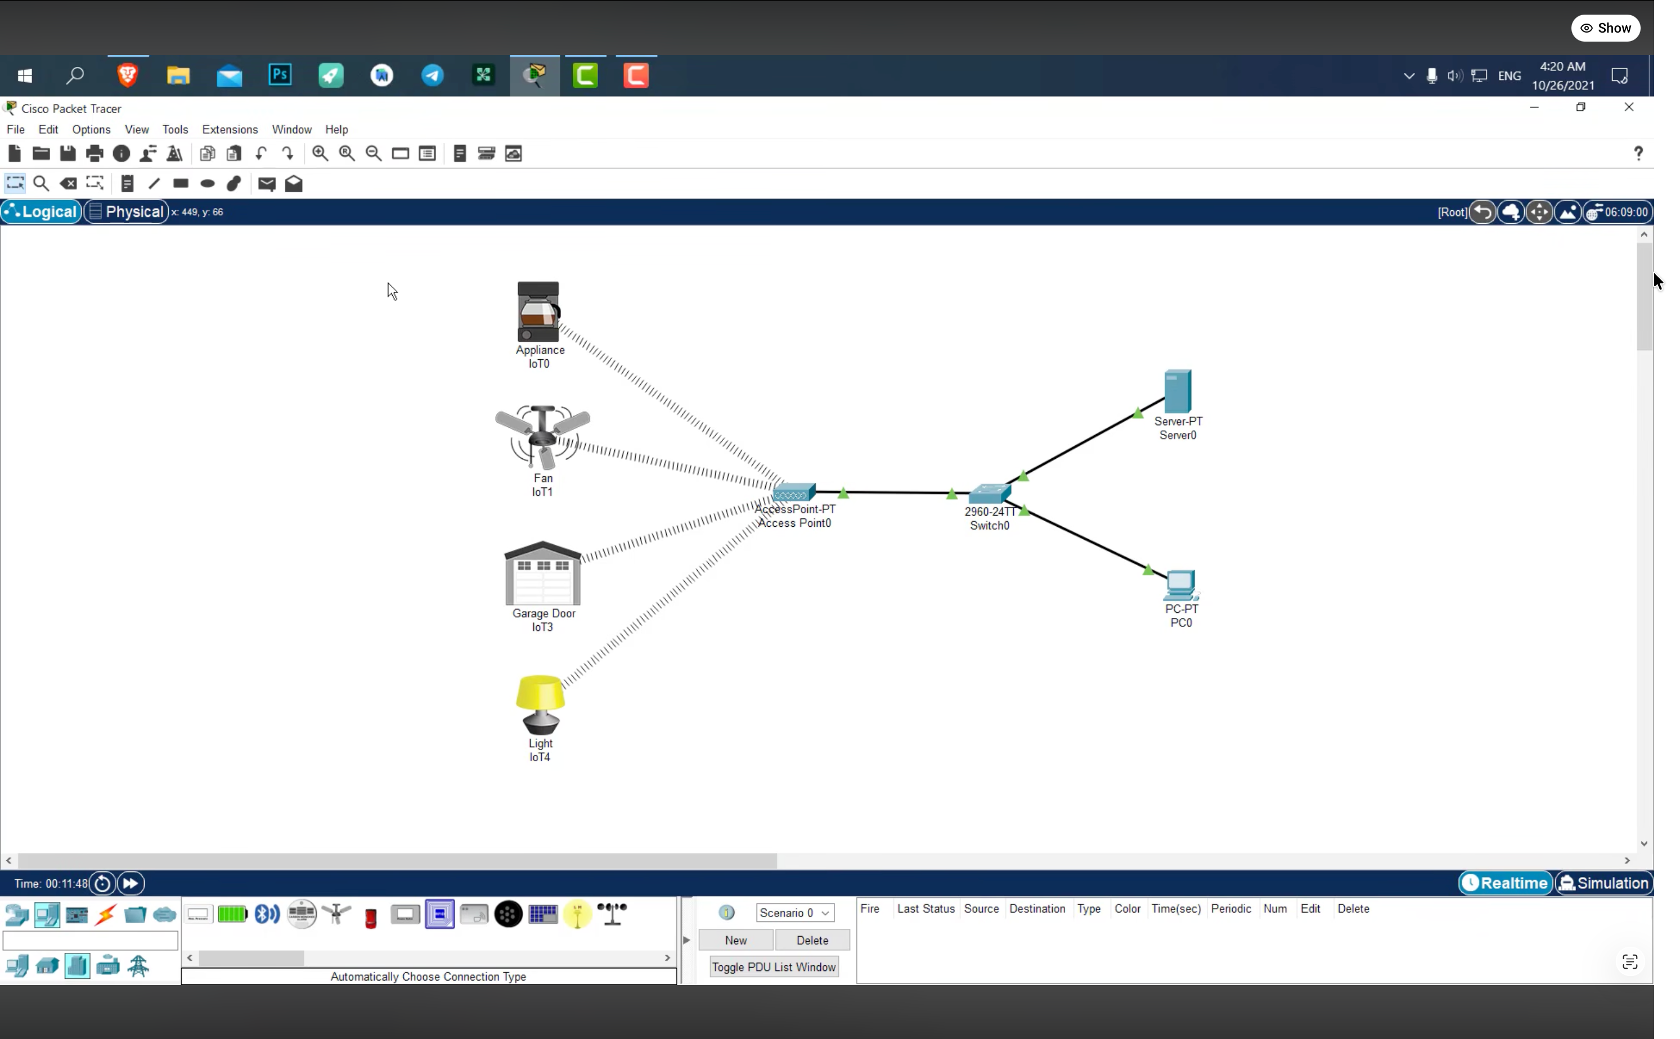

- IoT based AAA Local and Server based authentication configuration.
